App Reskinning: Mobile Demos

I redesigned a banking app to make it more user friendly and visually appealing. The application I have chosen has a lot of clutter and text and I tried to eliminate it by creating bigger icons and showing lesser number of options. In my opinion the new design is more accessible, easier to navigate and aesthetically pleasing.

This is the third iteration of my design. This time I fixed some buttons that I overlooked in the previous iteration, like the “Remember Me” toggle button during the Login page. Also, I created dark mode versions for all the pages I redesigned, which required changing the colors in all the artboards, components, and their states. This was the part where attention to detail was of utmost importance.

The techniques I learnt while doing this assignment have been very useful. Creating dark mode versions of the pages helped me understand how coloring and contrast between colors works, which is essential for any design to be visually appealing.

**Video Walkthrough:** <https://www.youtube.com/watch?v=xHXRGZRvs6g>

**ORIGINAL**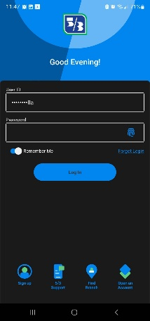 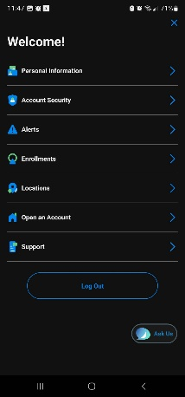 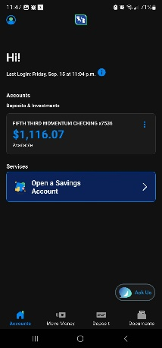 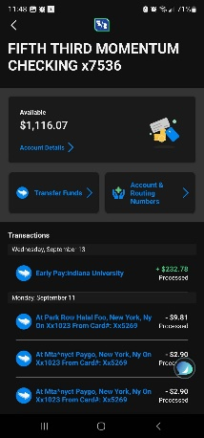 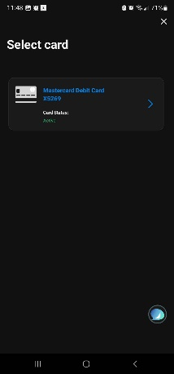 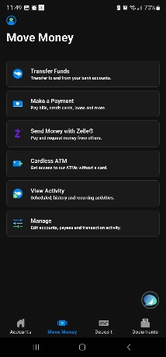

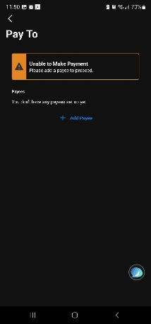 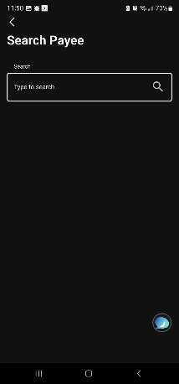

**Second Iteration (Light Mode)** 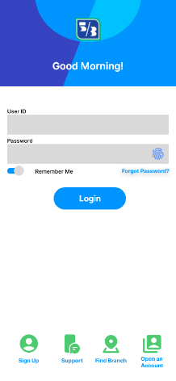 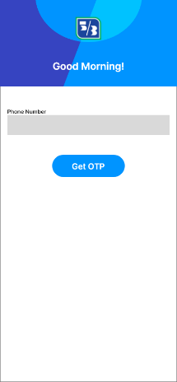 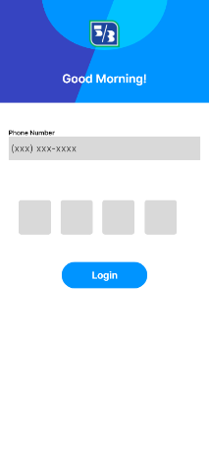 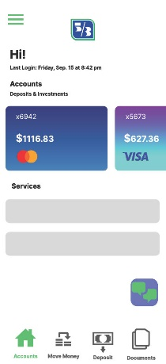 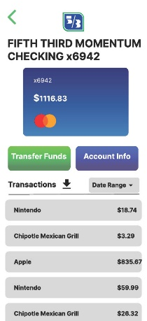 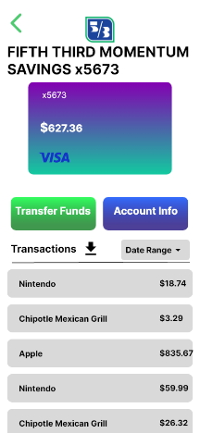

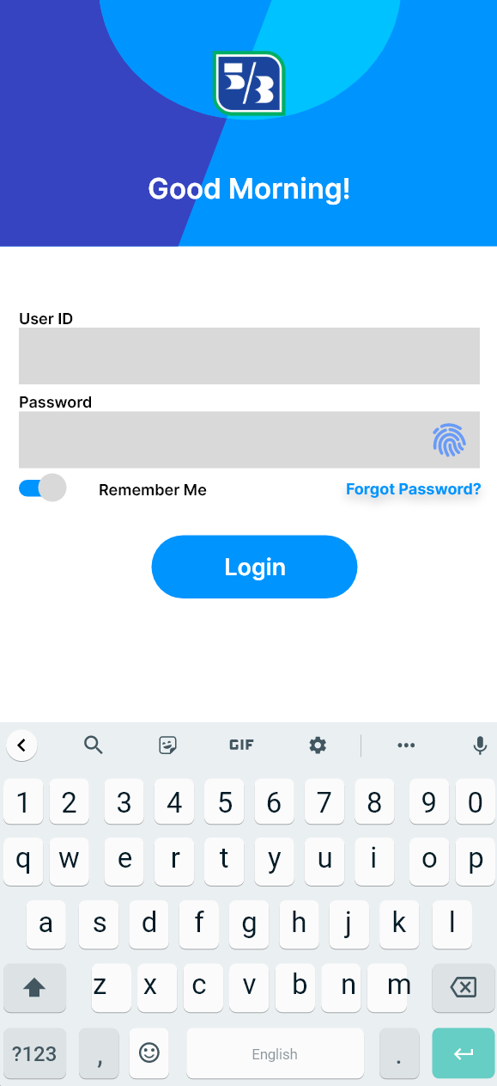 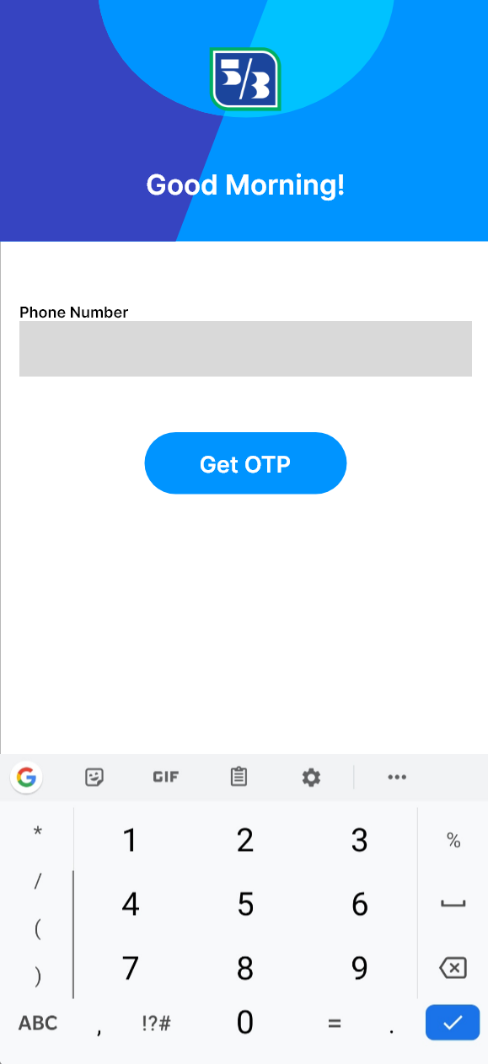 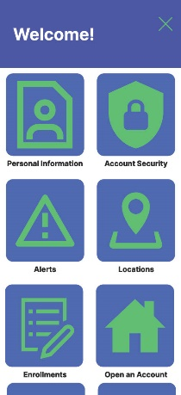 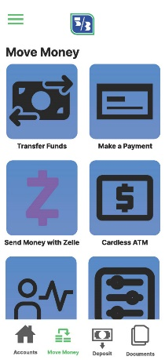 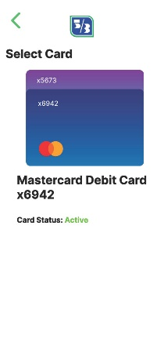 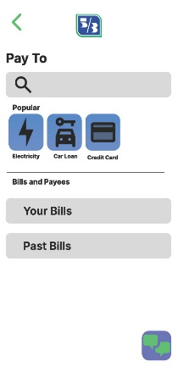

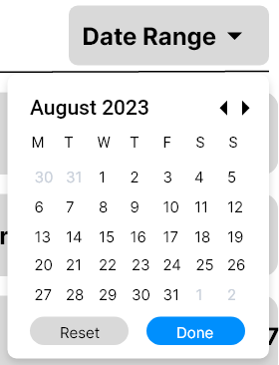 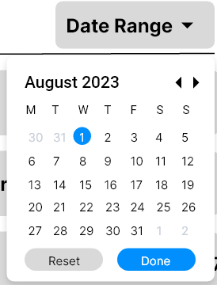 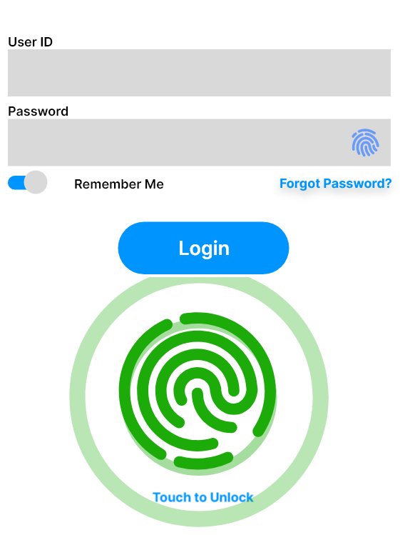   
   
New Splash Screen when you open the app.  
A preview of keyboards ()  
Added a drop down calendar created from scratch for the date range menu (statements screen).  
Users can login using fingerprint and the fingerprint reader has been animated.

**Third Iteration (Dark Mode)**All screens have been remade in dark mode for lesser strain on the eyes during the night (Dark mode is now a common preference for all users, so it’s being implemented by all apps)  
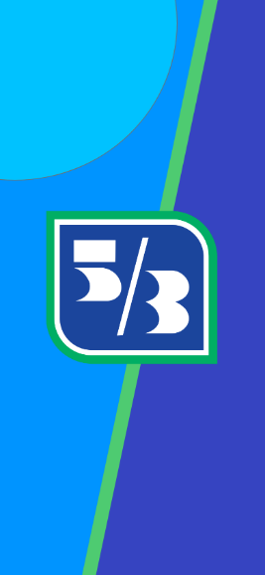 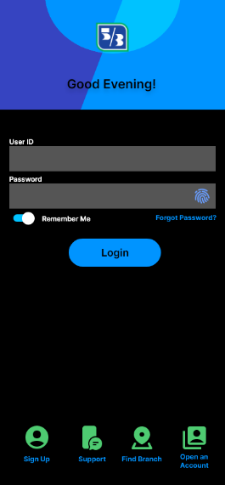 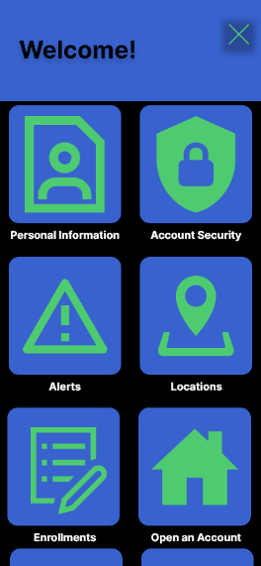 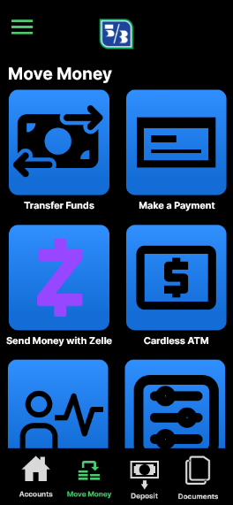 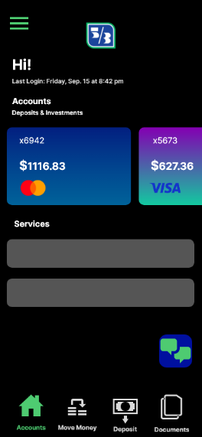   
  
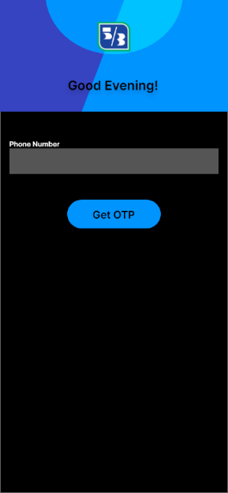 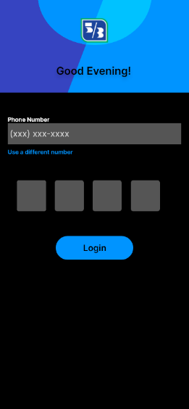 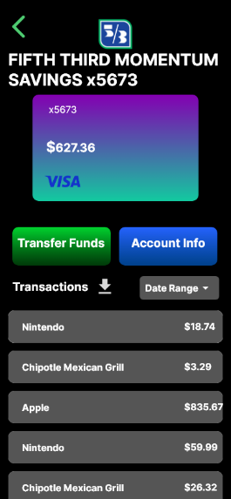 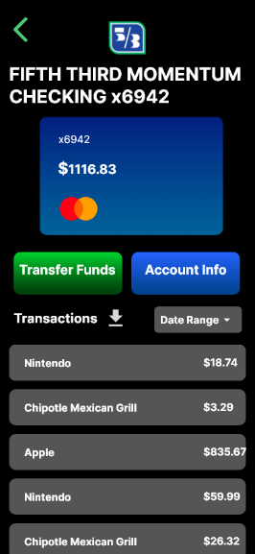 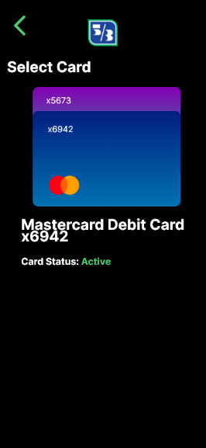  
  
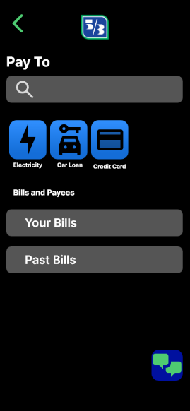   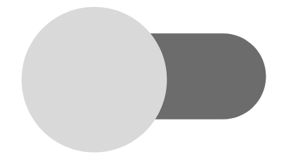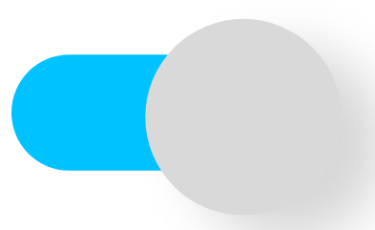  
 Toggle Buttons for “Remember Me” during Login (also in light mode)